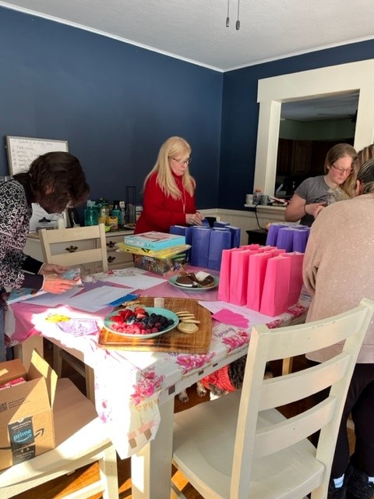
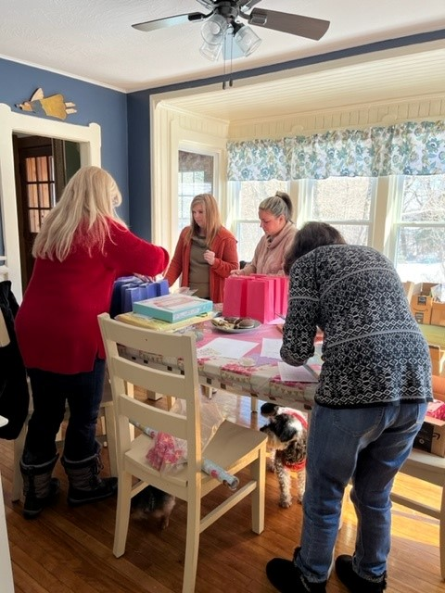
No Birthday Left Behind
"Every Child deserves to feel special on their Birthday"

Massachusetts Chapter

Melody Beach
Massachusetts Chapter Director
508.330.0343
centralmassnblb@gmail.com
Facebook private
Facebook public

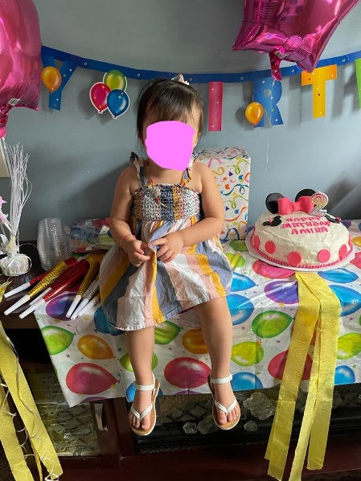
NBLB’s corporate mission is to provide every homeless shelter child the opportunity to celebrate their birthday in a special and memorable way.
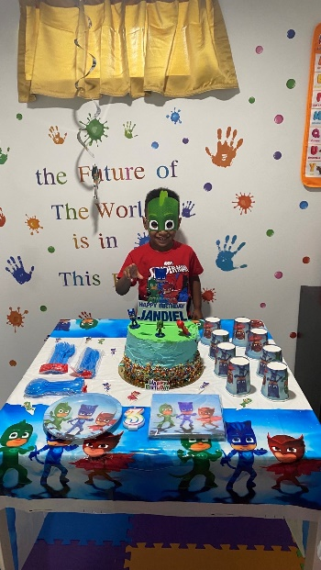
Nationally:
- Currently supporting 31 homeless shelters across the country
- Growing the NBLB family across the US to now include 10 chapters
- Aim to add two (2) new chapters in New York and Denver areas - places where rates of homelessness have gone up more since covid
- Reach for local and national grant offerings to sustain this

Locally:
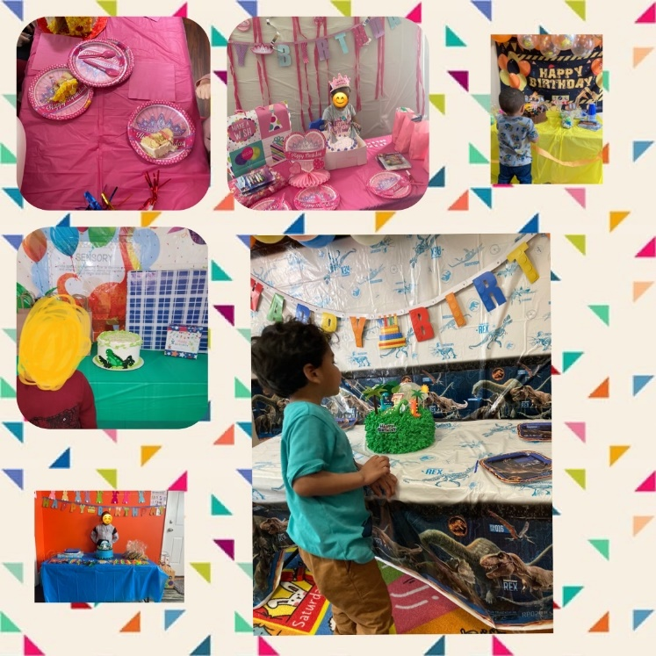
- Currently serving shelters in Worcester and Roxbury MA
- Collaborating with The Center of Hope Foundation
- Reach for local donation and grant offerings to sustain this
- Increasing Chapter growth by adding additional locations
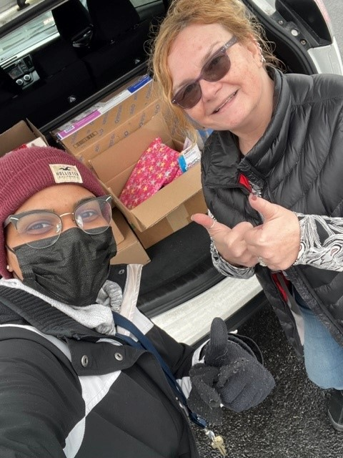
NBLB is a registered non-profit 501(C) (3), Tax ID # 84-1822037
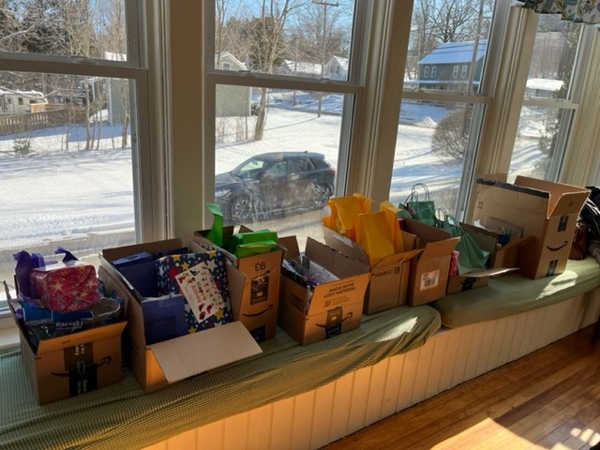

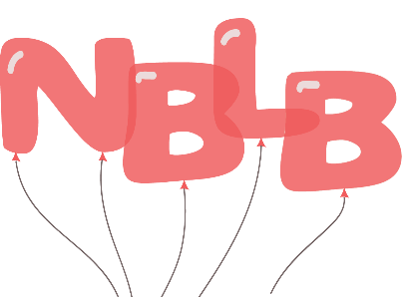
Wish List items – Amazon & Walmart along with Good Bag Item & Party Items

